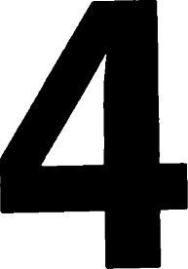Geometry the sphere

# Introduction

We now turn to a study of spherical geometry. Although the analytic geometry of the sphere is best formulated by considering it as a subset of three-dimensional space, our intuitive motivation must be intrinsic. In other words, our geometrical statements must be concerned with the sphere itself, not the points of space that lie inside or outside it. Our point of view is that of a small bug crawling on the two-dimensional surface of the sphere. Concepts of point, line, distance, angle, and reflection will be chosen to coincide with the bug's experience. (See [1], Chapter 5; [30], Chapter 2.)

# Preliminaries from E3

Of course, there is a three-dimensional Euclidean geometry analogous to the geometry of E2 , which is worthy of study in itself. In this book, however, we are restricting our attention to two-dimensional geometries. It is convenient for computational purposes to regard some of these geometries as subsets of E3 , and thus a few facts about the geometry of E3 will be developed. In a manner quite similar to that used in Chapter 1, we introduce the coordinate three-space R3 (also a vector space), an inner product, and the concept of length of a vector. In particular, if x = (Xl, x2, x3) and y = (Yl, Y2, Y3), then



CX = (CXI, CX2, CX3),

X IYI + X2Y2 + X3Y3,



Theorems 1—8 of Chapter 1 apply equally well in this setting. The reader

can easily check this by using the same proofs or trivial modifications of The cross product them.

The theorem of Pythagoras (Theorem 12, Chapter 1) is equally valid in E3 with the same proof. The definition of is peculiar to E2 , however. Instead, we have the cross product, which is treated in the next section.

# The cross product

The problem of finding a vector perpendicular to two given vectors is solved as follows: u X v

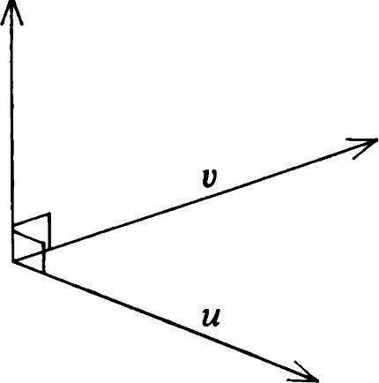Definition. Let u and v be vectors in R3. Then u x vis the unique vector z such that, for all x e R3 ,

(z, x) = det(x, u, v).

Theorem 1.

1. u x v is well-defined.
2. 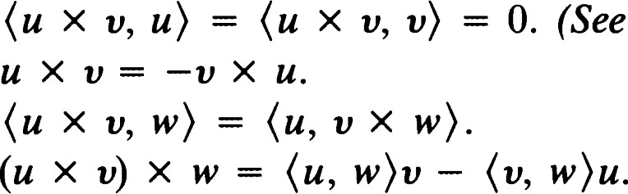= O. (See Figure 4.1.) Figure 4.1 The cross product u x v.

iii.

iv. v.

Proof: We first recall a result from linear: algebra; namely, that every linear function from R3 to R can be expressed in the form



for some fixed vector z (Theorem 8D). As we know, the function

## det(x, u, v)

is linear for each fixed choice of u and v. This proves (i). Identities (ii)—(iv) can be easily deduced from the properties of determinants. On the other hand, (v) (often called the vector triple product formula) is rather complicated, but detailed computation can be avoided by exploiting the linearity. First, observe that

€3, — El, and €3 X El —

Thus,

(El X €2) X €3

(€2

(€3 X85

the By linearity we have



By symmetry the analogous identity is true when €3 is replaced by El or €2. Finally, by linearity



Corollary.

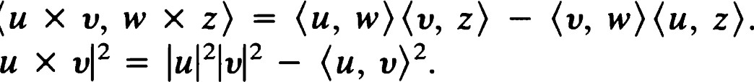i. u x v = O if and only if u and v are proportional. ii. If u x v * 0, then {u, v, u x v} is a basis for R3 . iii.

iv.

This last statement is known as the Lagrange identity. Note that it yields another proof of the Cauchy—Schwarz inequality.

Proof: (i), (iii), and (iv) can be easily deduced from the results of the theorem. (See Exercise 1.) For (ii) we will show that the set of vectors in question is linearly independent. Then general results from linear algebra (Appendix D) can be applied.

Now if there exist numbers X, p, v with



we can take inner product with u x v to obtain vlu X v1 2

and, hence, v = 0. Further, taking cross products with v and u, respectively, yields



so that = = O.

# Orthonormal bases

A triple {u, v, w} of mutually orthogonal unit vectors is called an orthonormal triple.

Theorem 2. If {u, v, w} is an orthonormal triple, then for all x e R3 x, u)u + (x, + (x, w)w.

The proof of this is similar to that of Theorem 9 in Chapter 1. In light of this result we usually refer to such a triple as an orthonormal basis.

Theorem 3. If u is any unit vector, there exist vectors v and w so that {u, v, w} is an orthonormal basis.

Proof: Let be any unit vector other than ±u. Then let v be u x divided by its length, and w = u x v. Noting that lu x VI2 = lu121v12 — (u, we see that {u, v, w} is orthonormal.

# Planes

A plane is a set Il of points of E3 with the following properties:

1. Il is not contained in any line.
2. The line joining any two points of Il lies in Il. iii. Not every point of E3 is in n.

Theorem 4.

1. If vand w are not proportional, and Pis any point, then P + [v, w] is a plane. We speak of the plane through P spanned by {v, w}.
2. If P, Q, and R are noncollinear points, there is a unique plane containing them. In this case we speak of the plane PQR.
3. If N is a unit vector and P is a point, then {XI<X — P, N) = 0} is a plane. We speak of the plane through P with unit normal N. See Figure

Notation: [v, w] = {tv + swlt, s e R} is called the span of {v, w}

Proof:

i. Suppose that a = P + [v, w] is a set as described in (i). We show that a is a plane. First of all, let Q = P + v and R = P + w. Then, because Q — P and R — P are not proportional, the points P, Q, and R are not collinear and a is not contained in any line. Secondly, if X — P + v x w, we see that X a because {v, w, v x w} is a linearly independent set. Thus, not every point of E-3 is in a. Thirdly, let

X = P + x IV + x2w, Y = P + y IV + Y2W be points of a, and let t be any real number. Then

(1 - OX + tv = (1  — t)X1 + tY1)v

— t)X2 + tY2)w = P + ((1 — t)Xl + tYl)V + ((1 - t)X2 + th)w.

This exhibits a typical point of XY as a member of a and concludes the proof that a is a plane.

iii. Let P, Q, and R be noncollinear points. Let v = Q — P and w = R — P. Then, by (i), P + [v, w] is a plane containing P, Q, and R. We

Planes

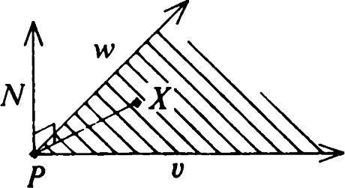

Figure 4.2 X lies on the plane through P with unit normal N.

now show that this plane is unique. Let fl be any plane containing P, Q, and R. Then

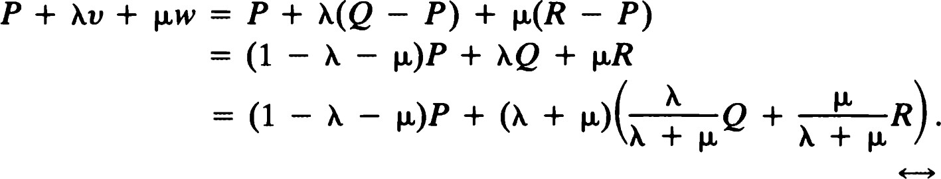

This exhibits a typical point of P + [v, w] as a point on the line PX, where

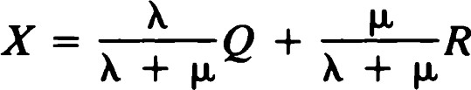

is a point on QR. Thus, any plane containing P, Q, and R must contain P + [v, w]. But now if fl contains a point S not in P + [v, w], then {S — P, v, w} is a linearly independent set. If Z is any point of E3 , Then

Z — P = kv + + v(S — P) for some numbers X, p, and v.

One can now check that

z = vs + (1 ( 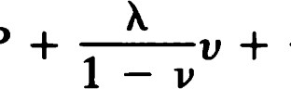l t vw),

which shows that every point of E3 is on a line joining S to a point of fl. This is impossible because Il does not contain all of E3 . We conclude that fl = P + [v, w] and that the plane containing P, Q, and R is unique.

ii. Finally, we relate characterizations (i) and (ii) of planes. Suppose the unit normal N is given. Then (by Theorem 3) we may choose v and w so that {N, v, w} is orthonormal. For any X in E3 we may write, by Theorem 2,



which shows that X — P lies in [v, w] if and only if (X — P, N) Thus, {xl(x - P, N) = 0} is a plane.

# Incidence geometry of the sphere

The sphere S2 on whose geometry we will be concentrating is determined by the familiar condition s2 = {x E3 1 IXI = 1}.

If one begins at a point of S2 and travels straight ahead on the surface, one will trace out a great circle. Viewed as a set in E3 , this is the intersection of

S2 with a plane through the origin. However, from the point of view of our bug on S2 it is more appropriate to call this path a line. This motivates the following definition.

Definition. Let be a unit vector. Then

C = {x e S2 1(E, x) = O}

is called the line with pole E. We also call e the polar line of E.

Remark: Spherical geometry is non-Euclidean. This means that whenever we represent a figure by a diagram, distortions are inevitable. Diagrams that faithfully represent one aspect (e.g., straightness of lines) will distort some other aspect (e.g., lengths and angles). You are cautioned against basing arguments on a diagram, but you are encouraged to use them to suggest facts that can then be verified rigorously. Often it is desirable to have more than one diagram of the same situation, each providing insight, yet containing some misleading information. Figures•4.3 and 4.4 show two ways of thinking about a point and its polar line.

Two points P and Q of S2 are said to be antipodal if P = —Q. Lines of S2 cannot be parallel, and two lines intersect not in just one point but in a pair of antipodal points. We assert the following facts that you may verify as exercises (Exercise 5).

Theorem 5.

i. If is a pole of e, so is its antipode —E. ii. If P lies on e, so does its antipode —P.

However, once these facts are noticed, there are no further anomalies, and we get the following analogues of the Euclidean results.

Theorem 6. Let P and Q be distinct points of S2 that are not antipodal. Then there is a unique line containing P and Q, which we denote by PQ.

Proof: In order to determine a candidate for PQ, we need a pole E. This must be a unit vector orthogonal to both P and Q. Because P and Q are not antipodal, we may choose equal to (P x Q)/IP x Q. Clearly, the line with pole passes through P and Q.

We now consider uniqueness. If is a pole of any line through P and Q, we must have



Thus, by the triple product formula, in Theorem 1,

## Incidence geometry of the sphere

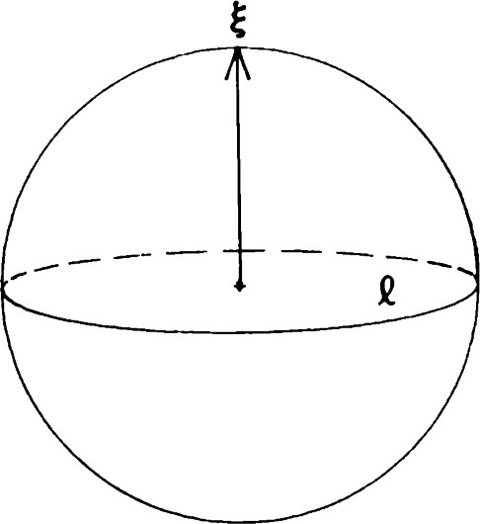

Figure 4.3 A point and its polar line e, first view.

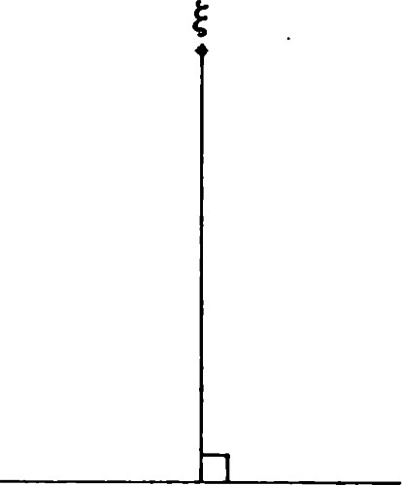

2 Figure 4.4 A point and its polar line e, second view.

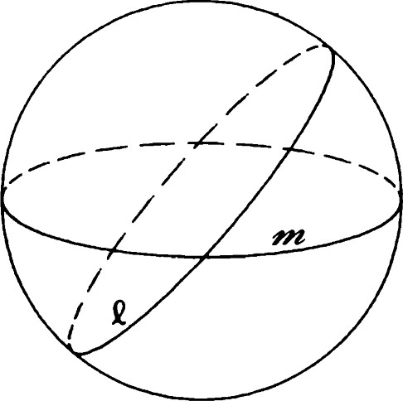

Figure 4.5 Two intersecting lines e and m, first view.

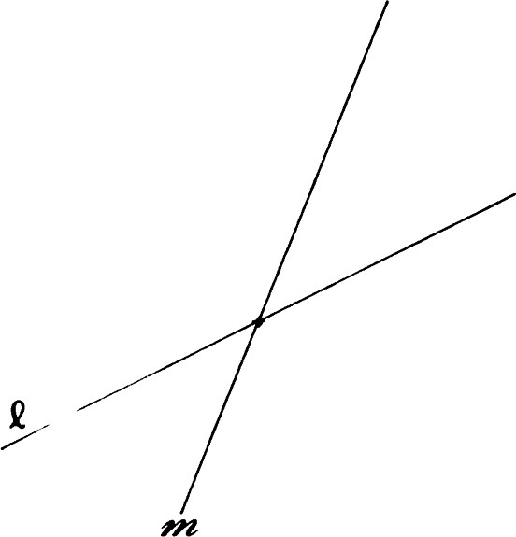

Figure 4.6 Two intersecting lines C and m, second view.

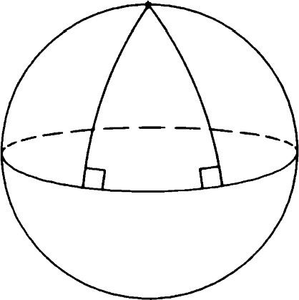

Figure 4.7 Even lines with a common perpendicular are not parallel, first view.



and, hence, is a multiple of the nonzero vector P x Q. Because = 1, we must have = Thus, PQ is uniquely determined.

Theorem 7. Let e and m be distinct lines ofS2 . Then e and m have exactly two points of intersection, and these points are antipodal. (See Figures 4.5 and 4.6.)

Proof: Suppose and T) are poles of e and m, respectively. Because e and m are distinct, * and, hence, x * O. But clearly, both points x 'Q)//IE x lie in the intersection. Any third point, however, could lie on at most one of e and m by the uniqueness part of the previous theorem.

Corollary. No two lines of S2 can be parallel.

Remark: Even lines that have a common perpendicular will intersect. See Figures 4.7 and 4.8 for two views of this situation.

# Distance and the triangle inequality

The distance between two points P and Q of S2 is defined by the equation d(P, Q) = cos -l <P, Q).

This definition reflects the idea that the measure of the angle subtended at the center of the sphere by the arc PQ should be numerically equal to the length of the arc. See Figures 4.9 and 4.10. The following theorem should be compared with Theorem 5 of Chapter 1.

Theorem 8. If P, Q, and R are points of S2 , then



ii. d(P, Q) = 0 if and only if P = Q. iii. d(P, Q) = d(Q, P).

iv. d(P, Q) + d(Q, R) d(P, R) (the triangle inequality).

Proof: Properties (i)—(iii) follow from the Cauchy—Schwarz inequality and the properties of the cos -l function. (See Appendix F.) The details are left to the reader as exercises. We concentrate our attention on the triangle inequality.

Let r = d(P, Q), p = d(Q, R), and q = d(P, R). By the Cauchy— Schwarz inequality we have

(P x R, Q x < IP x RF IQ x RE.

Applying Theorem 1, we get that the left side reduces to

(00 , R) - (P,  = (cos r — cos q cos p) 2,

and the right side is

— cos2 q)(l  cos2 p) = sin2 q sin p.

Thus, cos r — cos q cos p < sin q sin p, and, hence,

cos r < cos(q — p).

Because the cosine function is decreasing on [0, IT], we have r q — p, and, hence, r + p q, provided that 0 < q —p < T. But if q — p < 0, then q < p < r + p in any case. Furthermore, q — p > is impossible.

We conclude therefore that

d(P, Q) + d(Q, R) d(P, R), as required.

Corollary. If equality holds in (iv), then P, Q, and R are collinear.

Proof: In the proof of (iv), r = q — p implies that the Cauchy—Schwarz inequality is an equality. Thus, P x R and Q x R are proportional. Assuming that P x R * 0 (otherwise P, Q, and R are automatically collinear), we see that the pole of the line PR is proportional to P x R and, hence, to Q x R. This shows that Q lies on PR.

Remark: In the case of E2 we get the further conclusion that Q is between P and R (Theorem 1.7). In spherical geometry we shall see that a similar result holds if we make the right definitions. (See Theorem 35 in this chapter.)

# Parametric representation of lines

Just as in E2 , it is often convenient to describe lines in parametric form. Suppose that e is a line with pole E. Let P and Q be chosen so that {E, P, Q}

## Parametric representation of lines

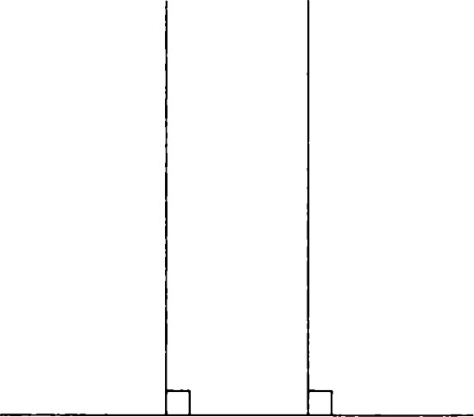

Figure 4.8 Even lines with a common perpendicular are not parallel, second view.

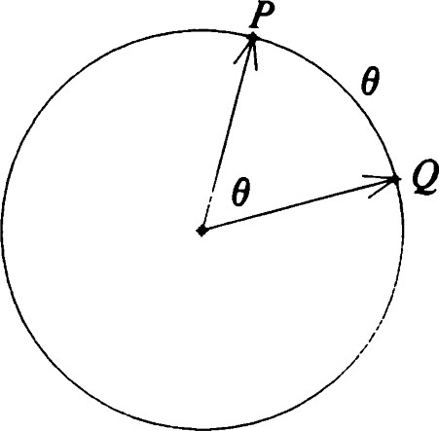

Figure 4.9 Distance in spherical geometry, first view.

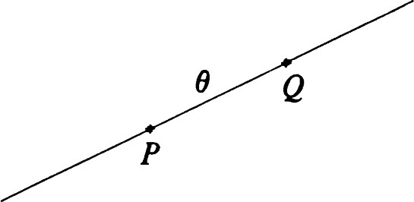

|  |
| --- |
| is orthonormal. Then set a(t) = (cos t)P + (sin t)Q• |

Figure 4.10 Distance in spherical geometry, second view.

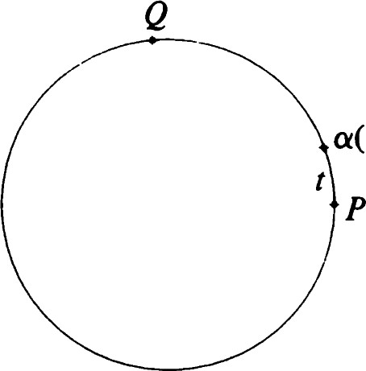

a(t)

Figure 4.11 Parametrization of a line, first view.

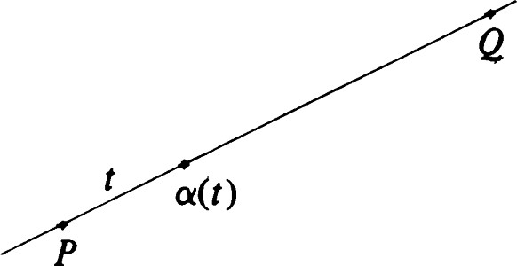

Figure 4.12 Parametrization of a line, second view.

Theorem 9.



1. Each poini of e occurs exactly once as a value of a(t) while t ranges through the interval [0, h).
2. a(t2)) = Itl t21 if 0 Iti

This essentially says that a is a unit-speed parametrization of the line e. See Figures 4.11 and 4.12.

The function a is said to be a standard parametrization of e. Each line has many standard parametrizations. P may be any point on e, and for a given P there are two choices of Q.

# Perpendicular lines

Definition. Two lines are perpendicular if their poles are orthogonal.

We recall that in the Euclidean plane a pencil of parallel lines could be regarded as a pencil of lines with a common perpendicular. In the spherical case we have the following situation. The proofs are left to the reader as exercises.

Theorem 10. Let e and m be distinct lines ofS2 . Then there is a unique line such that e -L n and m -L n. The intersection points of e and m are the poles of".

Theorem 11. Let e be a line ofS2 , and let P be a point. If P is not a pole of e, there is a unique line m through P perpendicular to e.

Remark:

i. If P is a pole of e, every line through P will be perpendicular to e. ii. Theorem 11 shows that as in E2 , we can drop a perpendicular from a point P not on e to the line e. In E2 the foot of the perpendicular is the point of e closest to P. In spherical geometry the perpendicular line m intersects e twice. We shall see later in this chapter that the points of intersection are the points of e closest to and farthest from P. We must postpone this discussion, however, until we have more machinery for dealing with segments, angles, and triangles.

Motions of S2

Definition. For any line e the reflection in is the mapping Oe given by

 = x - 2K x, e)e,

where is a pole of e. Motions of S2

It is not obvious that OCX will actually be a point of S2 . To take care of this and other difficulties, we investigate the properties of the transformation of R3 defined by the formula for Oe.

Theorem 12. Let (E, = 1 and define T: R3 -+ R3 by

Tx = x - 2<x, E)E.

Then

i. T is linear.

= (x, y) for all x, y e R3 .

Proof: The linearity of Tis an easy verification (Exercise 11); just use the linearity property of the inner product. To see (ii), consider

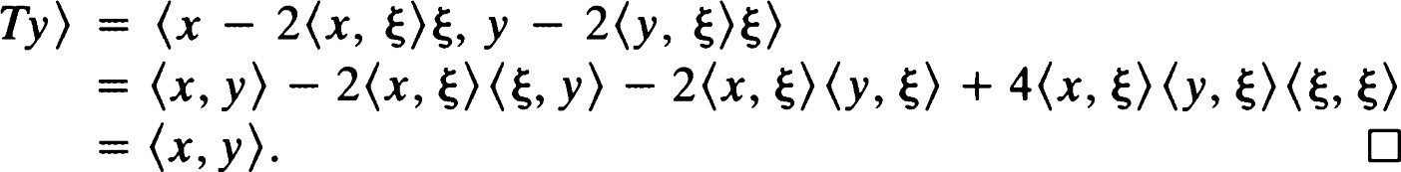

Remark:

1. A mapping T: R3 -9 R3 satisfying (i) and (ii) in Theorem 12 is said to be orthogonal. We study such mappings in general in a later section.
2. Property (ii) says that if = 1, then ITxl = 1. Thus, OCX is on S2 whenever X is a point of S2 . Other consequences of property (ii) and the algebra developed in Chapter 1 yield the following basic properties of reflections.

Theorem 13.

i. d(0ex, oeY) = d(X, Y) for all points X and Y in S2 . ii. OeOeX = X for all points X in S2 . iii. Oe: S2 -+ S2 is a bijection.

Theorem 14. OCX = X if and only if X e e.

We now investigate the product of two reflections. Let e and be distinct lines with respective poles and T). Let P be one of the points of intersection of e and m. Choose an orthonormal basis {el, e2, e3} with e3 = P. Then and are unit vectors in the span of {el, e2}. As in Chapter 1, we may choose numbers 0 and so that

 — ( —sin O)el + (cos 0)e2, = (—sin + (cos

A routine calculation [essentially that of Chapter 1, (1.11)] gives

ocel = (cos 20)e1 + (sin 20)e2,

= (sin 20)e1 — (cos 20)e2,

Thus, in terms of the basis {el, Q, e3}, Oe has the matrix

|  |  |
| --- | --- |
| cos 20 | sin 20 0 |
| sin 20 | —cos 20 0 |
| o | o 1 |

which we may abbreviate as

ref 0 

Similarly, the matrix of 0M is

ref 

and, hence, OeO„ has the matrix.

rot 2(0

We use the same definition for rotation as in E 2.

Definition. If a and ß are lines passing through a point P, then the isometry OaOß is called a rotation about P. The special case a = ß determines the identity, a trivial rotation. If a * ß, the rotation is said to be nontrivial. We denote the set of all rotations about P by ROT(P). Note that ROT(P) SO(2).

The above calculations reduce the algebra of rotations about a point P to that used in E2 . Thus, it is easy to verify the following important results concerning rotations of S 2.

Theorem 15 (Three reflections theorem). Let a, ß, and •y be three lines through a point P. Then there is a unique line through P such that



Theorem 16 (Representation theorem for rotations). Let T = OaOß be any member of ROT(P), and let C be any line through P. Then there exist unique lines m and m' through P such that

# T = oeo„ =

Definition. Let C be any line, and let m and n be perpendicular to e. The transformation is called a translation along e. If * n, the translation is said to be nontrivial.

Remark: Unlike the Euclidean plane, S2 does not have parallel lines. In fact, if two lines are perpendicular to C, then they intersect in the poles of C. Thus, our study of products of two reflections simplifies tremendously.

Theorem 17.

1. Every translation of S2 is also a rotation.
2. Every rotation of S2 is also a translation.

The translations along a line e in E2 were parametrized by the real numbers. If we take into account the periodic nature of our parametrization of lines of S2 , we can obtain the analogous relationships among reflections in lines perpendicular to C.

Consider now two lines a and ß perpendicular to C. Let P be an arbitrary point of C. Let be a pole of C, and let Q = x P. Then we may choose numbers a and b such that

(cos a)P + (sin a)Q e a, (cos b)P + (sin b)Q e ß.

Then it is easy to check that ( —sin a)P + (cos a)Q is a pole of a, and ( —sin b)P + (cos b)Q is a pole of ß. As we observed in dealing with

Motions of S2

rotations,

|  |  |
| --- | --- |
| cos 2a | sin 2a O |
| sin 2a | —cos 2a O |
| 0 | o 1 |
| with respect to the orthonormal basis | and, thus |

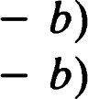cos 2(a — b) —sin 2(a oa0ß = sin 2(a — b) cos 2(a

|  |  |
| --- | --- |
| rot 2(a — b) O | 1 |

We denote the set of all translations along C by TRANS (C). The group generated by all reflections in the pencil of lines perpendicular to e is denoted by REF(").

Theorem 18. TRANS(C) is an abelian group that coincides with ROTC), where is a pole of C.

As a consequence of the preceding discussion, we can assert and interpret the following theorems.

Theorem 19 (Three reflections theorem). Let a, ß, and -y be three lines of a pencil with common perpendicular e. Then there is a unique fourth line b of this pencil such that

= 06.

Theorem 20 (Representation theorem for translations). Let T = OaOß be any member of TRANS(C). If m and n are arbitrary lines perpendicular to e, there exist unique lines m' and n' such that



Corollary. Every element of REF(9) is either a translation along e or a reflection in a line of 9.

Definition. If a and ß are lines perpendicular to a line e, then OaOßOe is called a glide reflection with axis C.

Remark: If {el, e2, e3} is an orthonormal basis with a pole of C, then el, Oee2 = —e3.

Corollary. With respect to an orthonormal basis of this type, a glide reflection with axis e has the form

cos X —sin X sin X cos X o 0 -1

Definition. An isometry that is a product of a finite number of reflections is called a motion.

Simplifying the proofs of Theorems 35—37 of Chapter 1 to take into account the absence of parallelism yields a proof of the following basic structure theorem for motions.

Theorem 21. Every motion is the product of two or three suitably chosen reflections.

# Orthogonal transformations of E3

Definition. A mapping T: E3 -9 E3 is said to be orthogonal if

i. T is linear.

96= (x, y) for all x, y e E3 .

|  |  |
| --- | --- |
| Theorem 22. A linear mapping T is orthogonal if and only if its matrix A | Orthogonal |
| (with respect to some orthonormal basis) satisfies A tA = I.  Proof: Suppose that T is orthogonal and that {4} is orthonormal. Then  akßk,  3 | transformations of E3 |



k.e=l

3

- E a„takJ

But < Tei, Tej) = <q, ej). Thus, A tA = 1.

Conversely, if A tA = I, with respect to some orthonormal basis, the same calculations show that



Thus, for any x = and y = Eyjej, the linearity of the inner product yields (TX, Ty)

Definition. A 3 x 3 matrix satisfying A tA = I is called an orthogonal matrix.

Remark: If A is an orthogonal matrix, then A—1 = A t , so that AA t — also. Finally, det(A tA) = (det = 1, so that det A = ± 1.

Theorem 23.

i. The set 0(3) of all orthogonal transformations ofE3 is a group called the orthogonal group of R3 ii. The set SO(3) of orthogonal transformations with determinant +1 is a subgroup of 0(3) called the special orthogonal group.

Proof: To prove (i), we check that the set of orthogonal matrices is closed under multiplication and the taking of inverses. First, note that if A and B are orthogonal, then

(AB)tAB = BtA tAB = BtB -

so that

(ABY = (AB) I

Next, if A is orthogonal, then

(A — ) = (A t)tA t = AA t

so that A -I is orthogonal. This completes the proof of (i).

To prove (ii), note that A, B e SO(3) gives det (AB) = (det A)(det B) =

1 • 1 = 1, so that the product AB is in SO(3). Secondly, if A e SO(3), then

det(A-l) = l/det A = 1/1 so that is also in SO(3).

# Euler's theorem

Earlier, we observed that every reflection and hence every motion may be regarded as arising from an orthogonal transformation. In this section we show the converse — every orthogonal transformation induces a motion of

It turns out that SO(3) corresponds precisely to the set of rotations whereas orthogonal transformations with determinant —1 correspond to reflections and glide reflections.

We first prove the following theorem of Euler.

Theorem 24. For each T in SO(3) there is an x in S2 such that Tx = x.

Proof: We begin by trying to solve an apparently harder problem. We attempt to find all nonzero vectors x in R3 such that Tx and x are proportional. This means that we must solve the equation



that is, (T — Xl)x = O for some real number X.

We know from Appendix D that a nontrivial solution would require that X satisfy det(T — RI) = O. The expression on the left is a polynomial of degree 3 in X called the characteristic polynomial. Write

char(t) = det(T - d).

There are two possibilities for factoring the polynomial:

1. char (t)— t) (three real roots).
2. 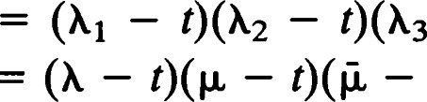char(t) = (X — t) (one real and two complex conjugate roots).

In either case there is, for each real root X, a unit vector x such that Tx Rx. In case (1)

ITx1 2 = kz?lx1 2 = X? ,

so that Xi = ± 1. On the other hand, the product of the roots must be equal

98 to the determinant of T, and, hence, at least one of the roots must be +1.

In the second case the product of the roots = must again be Euler's theorem +1. Therefore, X = +1.

Corollary. For any T e SO(3) the restriction of T to S2 is a rotation.

Proof: By Euler's theorem there is a point of S2 that is mapped to itself by T. Choose an orthonormal basis {el, e2, e3} with Te3 — e3. Then for suitable choice of 0,

= (cos O)el + (sin 0)e2, Te2 = ±((—sin O)el + (cos 0)e2), Te3 - 

by the same argument we used in the lemma to Theorem 38, Chapter 1. Because det T = 1, the positive sign should be used in Te2, and, hence, the matrix of T is

cos 0 —sin 0 0 sin 0 cos 0 0 o o 1

Because T can be factored into the product of two reflections, it is clearly a rotation.

Remark: Because every rotation arises from the product of two orthogonal transformations, it must be the restriction of a member of SO(3).

For all practical purposes SO(3) may be identified with the set of all rotations. In the future we will frequently use "is" when we really mean "arises from" or "is the restriction of," leaving it to the reader to make the distinctions when necessary.

Not all orthogonal transformations are rotations, of course. Definition. The antipodal map E is the transformation defined by

—x.

With respect to any orthonormal basis, E has the matrix

-1 o o

0 

The antipodal map is a glide reflection because it can be factored

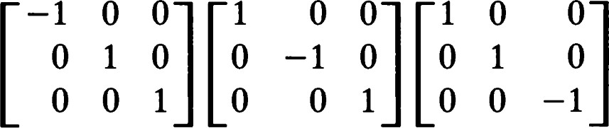

as the product of the three reflections in lines whose poles form an orthonormal basis. (Three lines of this type are said to form a self-polar triangle. Each vertex is a pole of the opposite side.) However, this glide reflection does not have a unique axis. Every line is an axis.

The antipodal map E is a convenient tool for analyzing orthogonal transformations.

Theorem 25. Every orthogonal transformation restricts to a motion of S2

Proof: Let T be orthogonal. If det T = 1, then Tis a rotation and, thus, a motion. If det T = —1, then ET is a rotation p. Thus, T = Ep. (Note that E is its own inverse.) This exhibits T as a motion.

## Isometries

Definition. A function T: S2 -+ S2 is an isometry if d(Tx, Ty) = d(x, y) for all x, y in S2

We recall that every reflection and hence every motion is an isometry. Further, we recall that every orthogonal transformation restricts to a motion of S2 . Because each orthogonal transformation is determined by its value on unit vectors, each isometry is the restriction of at most one orthogonal transformation. We now announce the major result of this section.

Theorem 26. For every isometry To of S2 there is an orthogonal transformation T coinciding with To on S2 .

Proof: Let {el, e2, e3} be any orthonormal basis of E3 . Because To is an isometry, we have Toei, Too) Kei, ej). Each point of E3 is of the form Xx for some x e S2 and k O. Define T: E3 —+ E3 by

T(kx) = if Rx * O,



We must now check that T is orthogonal. First we deal with linearity. For any x e S2 , Tr = Tox and

E (TX, Tei)Tei = E <x, ei)Tei

1 00 because {Tei} is also an orthonormal basis. Thus,

T(xx) = = XTx = (x, ei)Tei Further representation

= E (u, ei)Tq. theorems

In other words, for any u * O in E3 (and also more obviously for u = O) we have

u, q) Tei.

This expression is clearly linear in u. Furthermore, if v is another vector in

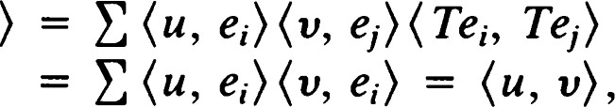

so that Tis orthogonal.

Fixed points and fixed lines of isometries

We now characterize the various types of isometries according to the nature of their sets of fixed points and fixed lines.

Theorem 27.

i. A nontrivial rotation has exactly two antipodal fixed points. ii. A reflection has a line of fixed points — its axis. iii. A glide reflection has no fixed points. iv. The identity leaves all points fixed.

Theorem 28. An isometry T leaves a line with pole e fixed if and only if TE

Theorem 29.

1. A half-turn leaves fixed lines all through a point (the center) and their common perpendicular.
2. A nontrivial rotation other than a half-turn leaves fixed only the polar line of its center.
3. A reflection leaves fixed its axis and all lines perpendicular to it (same fixed lines as half-turn).
4. A glide reflection other than the antipodal map leaves only its axis fixed.
5. The antipodal map and the identity leave every line fixed.

## Further representation theorems

Because the rotations constitute a subgroup of ef(S2), it is clear that the product of two successive half-turns is a rotation. It may surprise you to

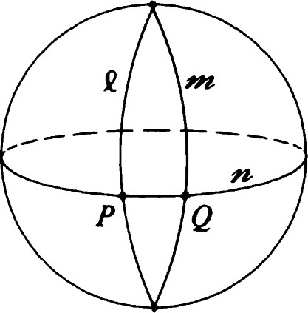

Figure 4.13 OeO„t = HpHQ.

# 102

learn that the converse is also true. Specifically, we have the following representation theorem for rotations:

Theorem 30. Every rotation can be written as the product of two half-turns.

Proof: Let T be a rotation. By Theorem 16 there are lines C and m such that T = 0€0„. Let n be a common perpendicular to e and m, meeting C and m in points P and Q, respectively. Then

T = 0000 = HpHQ.

Remark: In E2 the product of two half-turns is a translation, and every translation can be so represented. Theorem 30 points out an instance in which it is more productive to think of elements of SO(3) as translations rather than rotations. The construction is illustrated in Figure 4.13.

Theorem 31. Let P be a point of S2. Then for all x e S2 ,



Proof: Let and be poles of perpendicular lines through P. Then {E, n, P} is an orthonormal basis, and the identity x = (x, + (x, + (x, TI)TI

holds on S2 . Now it is a straightforward calculation that

- 2<x, - 2<x, TI)TI.

Putting these two results together yields the desired expression for Hpx. 

Corollary. Let P be any point of S2 , and let e be its polar line. Then

oeHp = Hpoe = E,

where E is the antipodal map.

Proof: The result of Theorem 31 may be written

## Hpx = -x - 2<-x, = -(x - 2<x, P)P)

for all x e S2 . In other words,

= = EOe•,

that is,

oeHp = 1--1poe = E.

We have shown that the antipodal map may be represented as the product of a half-turn and a reflection. We have also determined precisely

|  |  |
| --- | --- |
| what combinations can occur in the representation. We now do the same for arbitrary glide reflections.  Let T be a glide reflection other than the antipodal map E. Suppose that its axis C has a point P as a pole. We speak of P as a pole of T.  Theorem 32.   1. For each line m through P there is a unique point Q such that  T. The point Q will necessarily lie on e. 2. For each point Q on e, there is a unique line m such that 0m HQ = T.   The line m will necessarily pass through P.  Remark: For any line and any point Q, 0m HQ is a glide reflection whose axis is perpendicular to and passes through Q.  Segments  In spherical geometry the notion of betweenness is ambiguous. Given any three collinear points, it is possible to regard any one as being between the other two.  On the other hand, a choice of two points on a line C induces a decomposition of e into two subsets that behave much like segments do in E2 . We adopt the following definition.  Definition. A subseto ofS2 is called a segment if there exist points P and Q with (P, Q) = 0 and numbers ti < t2 with t2 — tl < 2n such that  = {(cos t)P + (sin t)Qlt1 t t2}•  Remark: All points of a segment are collinear. Each segment determines a unique line. On the other hand, a segment does not determine the data P, Q, h, t2 uniquely. In fact, we have  Theorem 33. Let o be a segment determined (as in the definition) by P, Q, ti, t2 and also by P, Q, tl, i2. Then   1. t2 = t2 — Fl. This number is called the length of the segment. 2. If we write a(t) = (cos t)P + (sin t)Q and ä(t) = (cos + (sin t)Ö, we have   {a(tl), a(t2)} = {ä(il), ä(i2)}•  These points are called the end points of o. All other points of o are called interior points of o. iii. P X Q = ±P x Q.  These points are the poles of the line on which o lies. | Segments  103 |

Proof: First, note that replacing Q by its negative, and [il, i2] by [—i2, -ill do not change conditions (i)—(iii). This allows us to assume that there is a number such that P = a(+) and Q = a(4) + T/2). A short computation now reveals that

ä(u) = (cos (u + + (Sin (u + = +

and, hence, that + 4, t2 + +1) =  A fundamental property of the trigonometric functions (see the lemma in Appendix F) shows that the two intervals are translates of each other mod h. In particulår, they have the same length and end points. Finally,

P x O = ((cos + (sin 4)Q) x ((—sin + (cos 4)Q) = (cos2 + sin2 x Q) = P x Q.

Corollary. Let A and B be arbitrary points satisfying (A, B) = 0. Leto be any segment lying on AB. Then there is a unique interval [a, b] such that 0 a < 21T and

 = {(cos t)A + (sin t)Bla t < b}.

Proof: First represent as

{(cos t)P + (sin t)Qlt1 t h},

where

1. = (cos + (sin and Q = (—sin + (cos

for some number $. (This is possible because is a segment.) Clearly,

(cos t)P + (sin t)Q = cos(t + + sin (t +

for all real t. Thus, we should choose a tl + mod 21T in the interval [0, h) and b = a + (t2

Theorem 34. Let A and B be nonantipodal points. Then there are exactly two segments having A and B as end points. Their union is the line AB, and their intersection is the set {A, B}.

Proof: Let be a unit vector in the direction [A x B], and set

1. = x A. Then there is a unique number L e (O, 21") such that B = (cos L)A + (sin L)Q. The segments

{(cos t)A + (sin t)QlO < t L}

and

{(cos t)A — (sin t)Q10 < t < 21T — L}

1 04 have A and B as end points. Because the second segment may be rewritten

{(cos t)A + (sin t)QlO t > L — 2T},

we see that the union of the segments is AB. The same observation shows that the two segments have no interior points in common and thus intersect only at their end points.

Definition. Let A and B be nonantipodal points. The longer of the two segments having A and B as end points is called the major segment AB. The shorter one is called the minor segment AB. The two segments are said to be complements of each other and may be referred to as complementary segments. See Figure 4.14.

Definition. If A and B are antipodal points, each of the (infinitely many) segments having A and B as end points is called a half-line.

Remark: The length of a minor segment AB is d(A, B). The length of a major segment AB is 21T — d(A, B). The length of a half-line is T.

Remark: In spherical geometry it is ambiguous to speak of the segment AB without specifying whether we mean the major or the minor segment.

Theorem 35. Let P, Q, and X be distinct points ofS2 . If P and Q are not antipodal, a point X lies on the minor segment PQ if and only if d(P, X) + d(x, Q) = d(P, Q). (4.1)

Proof: Choose P (orthogonal to P) so that the segment in question is

{(cos t)P + (sin t)PlO < t < L},

where L = d(P, Q)•

Assume first that X lies on the segment. Then we may write

X = (cos + (sin 4)P, (4.2) where e (O, L). We now verify (4.1) by computing d(P, X) = cos -l cos = and d(X, Q) = cos-l cos (L — 4) = L — 4.

Conversely, suppose that (4.1) holds. Then by the corollary to Theorem 8, X is on the line PQ, so the representation (4.2) holds for a unique number e (O, 2T). It can be verified (Exercise 33) that L < < 211T contradicts (4.1). The alternative, O < < L, must therefore hold, and X must lie on the minor segment PQ.

### Segments

minor segment

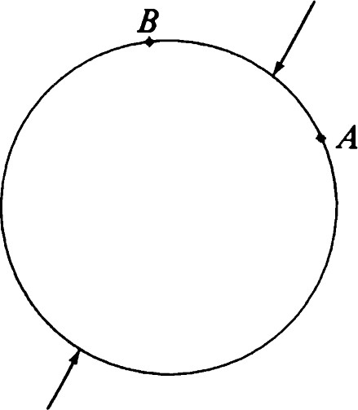

major segment

Figure 4.14 Complementary segments.

Remark: If P and Q are antipodal, the identity (4.1) holds automatically for all X on S2 .

Theorem 36. Let P and Q be antipodal points. Let R be any other point. Then the union of the minor segments PR and RQ is a half-line. If R the union of the four minor segments PR, RQ, PR' , and R' Q is the line PR.

Proof: Let P be a point on PR orthogonal to P such that

R = (cos L)P + (sin L)P,

where L = d(P, R). Then the minor segments in question are

|  |  |  |  |
| --- | --- | --- | --- |
| PR = {(cos | + (sin t)PIo | t | L}, |
| RQ = {(cos | + (sin t)PlL | t | IT} |
| PR' = {(cos | + (sin |  | t   - L}, |

R'Q = {cos + (sin - L  t  T}

But we may rewrite PR' and R'Q as

PR' = {(cos + (sin - L)  t  0},

R'Q = {(cos + (sin DPI-IT t

Now

PR = {(cos t)P + (sin < t < q} is the union of the four segments.

Theorem 37. Let T be an isometry. Then

i. If o is a minor segment, so is To. ii. If a is a half-line, so is To.

iii. If o is a major segment, so is To.

Proof:

1. Let be the minor segment AB. Then by Theorem 35

 = {Xld(A, X) + d(X, B) = d(A, B)}.

Thus,

To = {TXld(A, X) + d(X, B) = d(A, B)}

= {TXld(TA, TX) + d(TX, TB) = d(TA, TB)} = {Yld(TA, Y) + d(Y, TB) = d(TA, TB)}.

Again applying Theorem 35, we see that To is a minor segment with 1 06 end points TA and TB.

1. Let be a half-line lying on a line e and having end points A and B. Let C be any other point of a. Then is the union of the minor segments AC and CB. Thus, To is the union of the minor segments with end point sets {TA, TC} and {TC, TB}. Furthermore, TA and TB are antipodal. We conclude that To is a half-line.
2. Suppose that A is a major segment with end points A and B. We know that T takes the minor segment AB to the minor segment with end points TA and TB. Because T takes the line e = AB to the line through TA and TB, it must take the complementary segment to the corresponding major segment on TC.

## Rays, angles, and triangles

In spherical geometry we define a ray to be a half-line with one end point removed. The other end point is called the origin of the ray.

Suppose that PQ is a minor segment of length L represented in the standard way by

{(cos + (sin t)Plo t L}.

Then

PQ = {(cos + (sin t)PIo < t < IT}

is the unique ray through Q with origin P.

We can define angle just as we did in E2 . In this case a straight angle (as a set of points) is just a line with one point removed.

Deflnltlon. Let 4 PQR be an angle. A point X is in the interior of the angle if the minor segment XP does not intersect QR and the minor segment XR does not intersect QP.

The set of points in the interior of an angle is called a lune. A pair of distinct lines decomposes S2 into four lunes.

Remark: Each line e decomposes S2 into two half-planes. Half-planes may be defined as in E2 , except that the segments used in the definition are minor segments. A lune is the intersection of two half-planes. These ideas are developed further in Exericse 35. See also Figures 4.15 and 4.16.

Because rays no longer have direction vectors, we must find another way of defining the radian measure of an angle. Thinking in E3 for the moment, we see that the vectors that are poles of two intersecting lines are unit normals to these lines. Thus, the angle between the lines corresponds to the angle between these unit normals.

### Rays, angles, and triangles

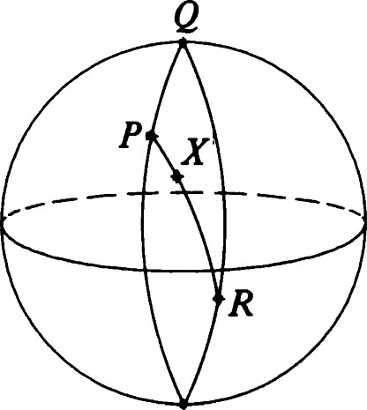

Figure 4.15 X is in the interior of OQR. 

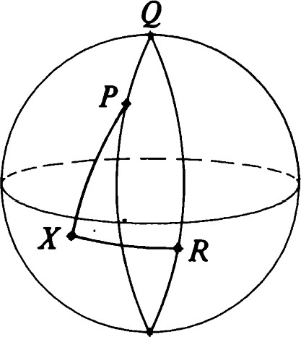

Figure 4.16 X is not in the interior of 4PQR.

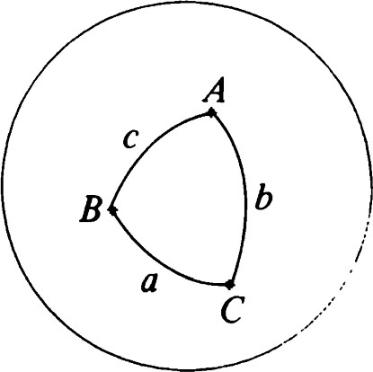

Figure 4.17 A triangle in spherical geometry, first view.

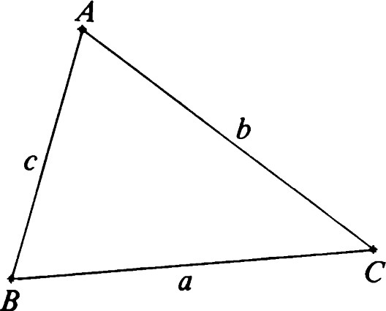

Figure 4.18 A triangle in spherical geometry, second view.

# 1 08

However, when two lines intersect, they determine four angles. How to choose the right sign when computing the radian measure of an angle is not as intuitively clear. The correct definition is the following:

Definition. The radian measure of an angle 4 PQR is cos-l<

IQ x PI' IQ x RI

Let P, Q, and R be three noncollinear points. The triangle PQR is defined to be the union of the three minor segments PQ, QR, and PR. The segments are called sides of the triangle, and the length of each side is equal to the distance between its end points.

The interior of a triangle is defined as in E2 .

Remark: Our definition of triangle is not the only possible one. However, it is the easiest to work with because it has the following properties:

i. Three noncollinear points determine a triangle. ii. Every triangle lies in some half-plane.

## Spherical trigonometry

Let ABC be a triangle. Let a be the length of the side BC, b the length of

AC, and c the length of AB. See Figures 4.17 and 4.18. Note that 1B x cp = IB1 2 1cp - (B, = 1 — cos2 a = sin2 a and



= cos a — cos b cos c. (4.3)

Hence, we have the spherical version of the Law of Cosines:

cos a — cos b cos c cos A =

sin b sin c

where we have written A as an abbreviation for the radian measure of 4BAC.

Now

### cos (b — cos a

1 — cos A — = 2 Sin2

sin b sin c 2

and cos a — cos(b + c)

1 cos A = = 2 cos2 

sin b sin c

### Thus Rectilinear figures

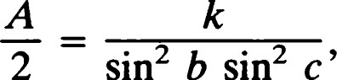sin2 A = 4 sin2 — cos2 2

where k is the product of the two factors

—2 sin and —2 sin 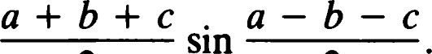



sin

2 2 2 2

Putting a + b + c = 2s, we have sin2 A 4 sin s sin (s — a) sin (s — b) sin (s c)

|  |  |  |  |
| --- | --- | --- | --- |
| sin2 a  and, hence, | sin2 a sin2 b sin2 c |  |  |
| sin A | 2(sin s sin(s — a) sin(s — b) sin(s | c)) 1/2 | (4.4) |
| sin a | sin a sin b sin c |  |  |

Note that the right side is symmetric in a, b, and c, so that we may conclude that

sin A sin B sin C sin a sin b sin c

This is the Law of Sines for spherical trigonometry.

There is a nice relationship between angles and sides of a spherical triangle that arises from the pole—polar correspondence. Each of the formulas we have developed has a counterpart with the roles of angle and side interchanged. In particular, we have the two versions of the Law of Cosines. The first was proved earlier in this section. The second is Exercise

37.

Theorem 38. In the notation of this section we have

cos a — cos b cos c

i. cos A = sin b sin c

(4.5) cos A + cos B cos C ii. cos a

sin B sin C

Corollary. The lengths of the sides of a triangle are completely determined by the radian measures of its angles.

## Rectilinear figures

We may define rectilinear figures as in Euclidean geometry. All the definitions and proofs are either exactly the same or very similar. In

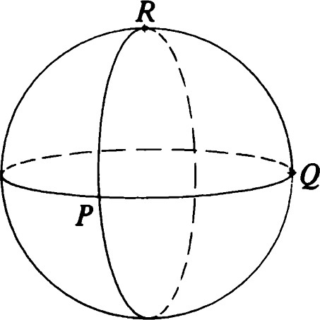

Figure 4.19 Theorem 40. Three mutually perpendicular lines.



# 1 1 0

particular, every symmetry of a rectilinear figure permutes the vertices. The vertices of a complete rectilinear figure on S2 occur in antipodal pairs. Thus, every symmetry also permutes the set of antipodal pairs of vertices.

In particular, let A be a triangle with vertices PQR. Let G be the stabilizer of P in g(A). Now G consists of rotations about P and reflections in lines through P. Every member of G must permute the set {Q, R}. If P lies on the perpendicular bisector m of QR, then 0M will be in G. However, if e = QR, oe will not be in G. Thus, G = {1} or G = {1, 0„}. Also, the orbit of P consists of at most three elements P, Q, and R. Thus, #9(A) < 3 x 2 = 6. If A is isosceles, then #9(A) = 2. If A is equilateral, then #9 (A) = 6. If A is scalene, #9(A) = 1.

These arguments show that as far as symmetry is concerned, spherical triangles behave just like Euclidean triangles.

Theorem 39. Let be a rectilinear figure having at least three noncollinear vertices. Then g(F) is a finite group.

Proof: Every symmetry of induces a permutation on the vertices. But a linear transformation is determined by its action on three linearly independent vectors because they form a basis (Theorem 4D). Therefore, there is at most one isometry realizing each permutation of the vertices of F. O

Theorem 40. Let ef be the complete rectilinear figure consisting of three mutually perpendicular lines. Then g(9) is a group of order 48.

Proof: Let P, Q, and R be poles of the three lines (Figure 4.19). Each permutation of the set {P, Q, R} determines an isometry whose matrix with respect to the orthonormal basis {P, Q, R} is a permutation matrix. (Each row and column has one 1 and two O's.) For each of the six permutation matrices, there are eight ways of introducing minus signs into the matrix. Each minus sign introduced corresponds to a reflection in one of the lines of the configuration.

Clearly, the 48 matrices so obtained are orthogonal and so define isometries of S2 . The isometries permute the lines of ef and so are symmetries. On the other hand, any symmetry must permute the set of antipodal pairs. It is easy to see that the given constructions yield all such permutations.

The group g (F) consists of 24 rotations, 9 reflections, and 15 glide reflections, including the antipodal map.

The figure decomposes S2 into four pairs of antipodal triangles. The symmetries of these triangles provide eight nontrivial rotations. There are also three nontrivial rotations about each of the three antipodal pairs of vertices. There are six half-turns about the midpoints of the segments of the figure. Finally, the identity rounds out our list of 24 rotations.

## Congruence theorems

Now that we have defined some geometrical objects — segments, rays, angles, triangles — we return to our study of the group of isometries of S2 and how they act on simple figures.

Theorem 41. Let P and Q be points ofS2. Then there is a unique reflection interchanging them.

Proof: (P- Q)/IP- Q I and let e be the line whose pole is E. Then

### oeP = P - 2 2 IP - Q1

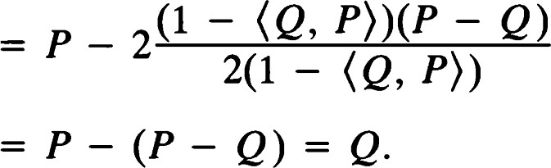

Thus, Oe interchanges P and Q.

To prove uniqueness, suppose that Oe and 0M are reflections that interchange P and Q. Then the rotation leaves both P and Q fixed. If P and Q are not antipodal, then OeO„ = I by Theorem 27, and e = m. If P and Q are antipodal, then the pole of e satisfies



Thus, P = (P, E)E, and e is the polar line of P. Because the same argument applies to m, we see that e = m.

Definition. Let be a segment. The perpendicular bisector ofÖ is the unique line e such that Oe interchanges the end points of o. See Figures 4.20 and 4.21.

Remark: The perpendicular bisector of is perpendicular to the line on which lies.

Theorem 42. The perpendicular bisector of a segment is the set of all points of S2 that are equidistant from its end points.

Proof: This is essentially Exercise 7.

Deflnltlon. The midpoint of a segment is its unique point of intersection with its perpendicular bisector.

Remark:

i. The midpoint M of a segment is the unique point of that is equidistant from the end points of o.

#### Congruence theorems

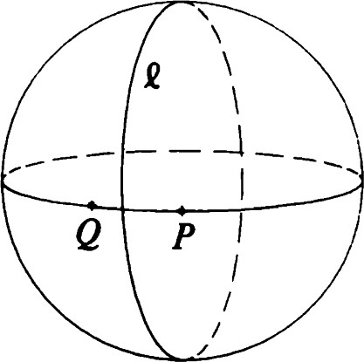

Figure 4.20 The perpendicular bisector of PQ, first view. Oe interchanges P and

Q.

2

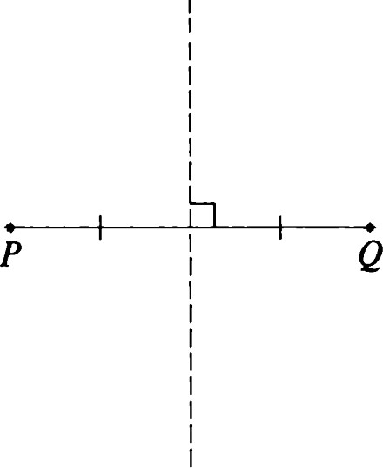

Figure 4.21 The perpendicular bisector of PQ, second view. Oe interchanges P and Q.

1 1 1

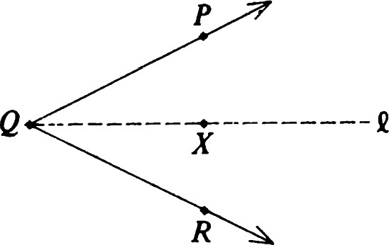

Figure 4.22 Oe interchange QP and QR.

## 1 1 2

ii. A segment and its complement have the same perpendicular bisector.

Theorem 42 also suggests a method for constructing an isometry that interchanges two given lines.

Theorem 43. There are exactly two reflections that interchange a given pair of lines.

Proof: Choose points P and Q so that the poles of the given lines are ±P and ±Q. The unique reflection that interchanges P and Q will interchange their polar lines; so will the unique reflection that interchanges P with —Q (and, hence, Q with —P).

On the other hand, any reflection that interchanges the lines must send P to Q or P to —Q. Thus, the two reflections mentioned are the only ones that interchange the given lines.

Theorem 44. For any angle there is a unique reflection that interchanges its arms.

Proof: We first look at the special cases — the zero angle and the straight angle. In both of these cases any such reflection must leave fixed the line e on which the arms lie and must also have the vertex as a fixed point. Hence, it is either Oe or where is the line through the vertex perpendicular to e. Clearly, Oe leaves the zero angle pointwise fixed while interchanges the arms of the straight angle.

Now let 4 PQR be an angle that is neither a zero angle nor a straight angle. To simplify the calculation, we may assume that (P, Q) = (R, Q) = O and that P x R = IP x RIQ. (Geometrically, this expresses the fact that PQ is the polar line of R.) Let e be the line whose pole is (P - R)/IP - RI. Note that (Q, E) = O, so that oeQ = Q. Also,

oeP = P - 200, = P - 2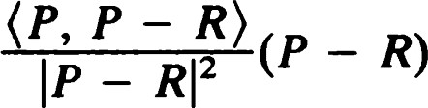

R.

Similarly, because IP — R1 2 = 2(1 — (P, R)), we get that OCR = Q, so that Oe interchanges the arms of d.

Deflnltlon. In the notation of Theorem 44 the ray QX, where X = (P + R)/IP + RI, is called the bisector of the angled = &PQR. See Figure

4.22.

Note that X is a point of e that lies in the interior of d.

Remark: Clearly, Theorem 44 provides a way of proving Theorem 43. Furthermore, if P and Q are any two nonantipodal points, and R is a pole of PQ, the reflection that interchanges the arms of 4 PRQ will also interchange P and Q. Thus. we can also deduce Theorem 41 from Theorem 44. However, the proofs of Theorems 41 and 43 are easier, and we have decided to include them separately.

We conclude this section with some results on angle addition. The proofs are left to the exercises, and we will not use the results in subsequent theorems. See also Theorem 7.42.

Theorem 45. If QX is the bisector of an angle 4PQR, then 4 PQX is congruent to 4RQX.

Theorem 46. Let 4 PQR be an angle, and let X be a point in its interior. Then the radian measure of 4 PQR is the sum of the radian measures of 4PQX and 4RQX.

Remark: In spherical geometry the angle sum for a triangle varies with the size of the triangle. It is easy to check, for example, that if {P, Q, R} is an orthonormal basis, then each angle of APQR is a right angle, so that the sum of the radian measures of the three angles is 3"/2. See Figure 4.23.

Theorem 47. Let P and Q be points on a line e. Then there is exactly one translation along e that takes P to Q.

Proof: Choose an orthonormal basis {el, e2, e3} such that el = P, Q

(cos e)el + (sin e)e2 for some e e [0, IT], and e3 = el x e2 is a pole of e. If T e TRANS(C), there is a number such that the matrix of T with respect to {el, e2, e3} is (by Theorem 17)

### cos —sin + O sin cos + 0 o 1

If T takes P to Q, then

Q = tel = (cos 4)e1 + (sin 4)e2.

Thus, 0 mod h, and T is determined uniquely by this condition. 

Theorem 48. Let P, Q, P' , and Q' be points (not necessarily distinct) lying on a line e. Suppose that d(P, P') = d(Q, Q'). Then there is an isometry T such that Q and TP' = Q'.

Proof: By first applying a translation along e, we can arrange that P = Q. Then P' and Q' are points of e that are equidistant from P. If P' = Q', we may choose T to be the identity, and we are finished. If not, let T = O

#### Congruence theorems

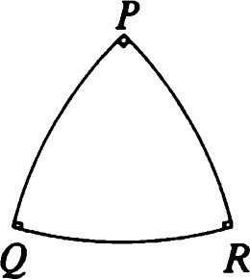

Figure 4.23 A triangle with three right angles.

1 1 3

the reflection that interchanges P' and Q' Then 0m leaves P fixed and sends P' to Q', as required.

Remark: According to the construction, T could be the identity, a translation, or a reflection.

Theorem 49. Two segments are congruent if and only if they have the same length.

Proof: Let and 02 be congruent minor segments. If T is an isometry taking to ö2, then T takes the end points of to those of (see proof of Theorem 37). As a result, and TOI = have the same length. If two major segments are congruent, so are their complements. Because we know that the complements have equal length, say L, the original major segments must have equal length IT — L.

Conversely, let and be segments of equal length. We may assume that they are minor segments, because if we find an isometry taking to 02, it must also relate their complements. First, apply a reflection (Theorem 43) to move to the line determined by 02. Now translate along this line to make one pair of end points coincide (Theorem 47). If the other pair of end points coincides, we are finished. Otherwise, they are equidistant from the common end point, and the required isometry is completed by applying the reflection that fixes the common end point and interchanges the other two.

### Symmetries of a segment

Theorem 50. Let be a segment lying on a line e. Let m be its perpendicular bisector, and M its midpoint. Then g (o) is the group {I, Oe, HM}. Its multiplication table is the same as that in Theorem 2.28.

Proof: Let be the minor segment PQ. (The major segment has the same symmetries.) It is easy to check that the four given transformations permute the set {P, Q} and, hence, are symmetries of U. (Theorem 37 applies here.) On the other hand, suppose that T is any symmetry of o. Then T permutes its end points, so that Tor 0M T leaves P and Q fixed. By Theorem 27 the only isometries of S2 leaving P and Q fixed are Oe and I. Thus, Tmust bel O O or O„Oe = HM.

### Right triangles

An important property of right triangles in Euclidean geometry is given by Pythagoras' theorem. In spherical geometry we have the following analogue. See Figure 4.24.

Theorem 51. Let ABC be a triangle on S2 with sides of length a = d(B, C), b = d(A, C), and c = d(A, B). If AC is perpendicular to AB, then cos a = cos b cos c.

Remark: Note that this is a special case of Theorem 38. However, a direct proof is instructive.

Proof: Let be a pole of AB. Then {E, A, x A} is an orthonormal basis with respect to which we may write (after replacing by —E if necessary)

C = (cos b)A + (sin b)e.

Also,

B = (cos c)A ± (sin x A).

Hence,

cos a = cos d(B, C) = cos cos -l (B, C) = (B, C) = cos b cos c.

Theorem 52. Let e be any line. Let X be a point that is neither on e nor a pole of e. Let m be the line through X perpendicular to e. Of the two points where e intersects m, let F be the one closest to X. Then for all points

y ±F on e,



Proof: We apply Theorem 51 with X = C, F = A, and Y = B. Note that b < T/2, so that cos a and cos c have the same sign. If both are positive, we have cos a = cos b cos c < cos b,

and, hence,



If both are zero, the same inequality holds because



Finally, if both are negative, we get b < IT/2 < a and

#### Right triangles

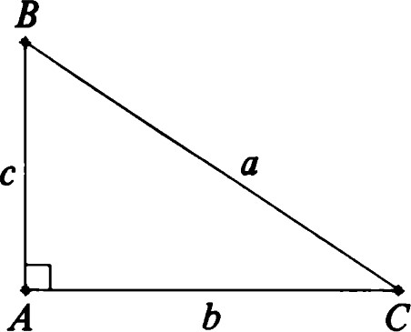

b

Figure 4.24 A right triangle, cos a = cos b cos c.

1 1 5

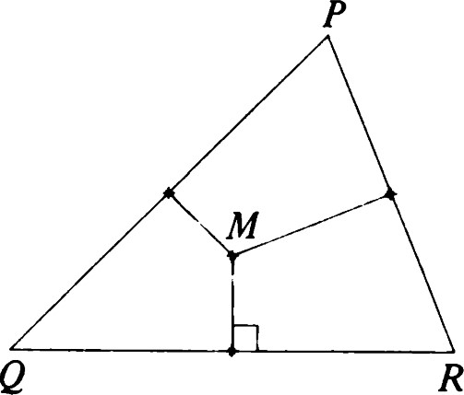

Figure 4.25 Concurrence of the perpendicular bisectors.

# 1 1 6

cos(1T — a) — cos b cos(1T — c) < cos b, so that IT — a > b, and, hence, b < a < IT — b, as required.

Remark: This means that F is the point of e closest to X, and —F is the point farthest from X.

Definition. F is called the foot of the perpendicular from X to e. The number d(X, F) is written d(X, C) and is called the distance from X to e.

## Concurrence theorems

Theorem 53. The perpendicular bisectors of the three sides of a triangle are concurrent. See Figure 4.25.

Proof: Let the triangle be APQR. Let M be a point where the perpendicular bisectors of sides PQ and QR intersect. Now d(M, P) = d(M, Q) and d(M, Q) = d(M, R). Thus, d(M, P) = d(M, R), and M lies on the perpendicular bisector of side PR.

Remark: The same theorem with the same proof is valid in E2 .

Theorem 54. Let P, Q, and R be noncollinear points of S2 . Let' = QR, q = PR, and = PQ be the three lines they determine. Let Ou be a reflection that interchanges and q, and let Ov interchange q and a. Then there is a line to concurrent with u and such that ou, interchanges and a.

Proof: Let M be a point of intersection of u and v, and let e be the line through M perpendicular to q. Using the three reflections theorem, choose to SO that ovoeou = ow.

Then

= ovoeouß = ovoeq as required.

Corollary. The lines containing the bisectors of the three angles of a triangle are concurrent.

Proof: Because there are two reflections that interchange' and u, we need only check that to is the one containing the bisector of 4PQR. This part of the proof requires some further calculation and will be left as an exercise (Exercise 40). Figures 4.26 and 4.27 illustrate the possibilities.

## Congruence theorems for triangles

Theorem 55 (SSS theorem). Let APQR and AP'Q'R' be such that d(P, Q) = d(P', Q'), d(Q, R) = d(Q', R'), and d(P, R) = d(P', R'). Then the two triangles are congruent.

Theorem 56 (SAS theorem). Let APQR and AP'Q'R' be such that d(P, Q) = d(P', Q'), d(Q, R) = d(Q', R'), and &PQR = 4P'Q'R' (in radian measure). Then the two triangles are congruent.

These two theorems are proved in a similar fashion to Theorems 1.40 and 1.41 by using the spherical versions of the tools used in the construction. Because sizes of angles determine lengths of sides in spherical geometry (Theorem 38), we get an additional congruence theorem.

Theorem 57 (AAA theorem). Let APQR and AP' Q' R' be such that &PQR = &P'Q'R', 4PRQ = &P'R'Q', and 4QPR = 4Q'P'R' (in radian measure). Then the two triangles are congruent.

Corollary. Two angles are congruent if and only if they have the same radian measure.

## Finite rotation groups

In plane Euclidean geometry we found a nice characterization of the finite groups that occur as symmetry groups of figures. All finite subgroups of J(E2) were shown to be cyclic or dihedral (Theorem 3.10).

The situation in spherical geometry is more complicated. In other words, figures can have a richer symmetry structure. The standard figures in E2 having the largest symmetry groups are the regular polygons. In spherical geometry we have, in addition to the regular polygons, the spherical versions of the Platonic solids — the tetrahedron, cube, octahedron; dodecahedron, and icosahedron.

We will restrict our attention to finite groups of rotations of S2 . All other finite subgroups of 0(3) are generated by adjoining a suitable reflection.

### Finite rotation groups

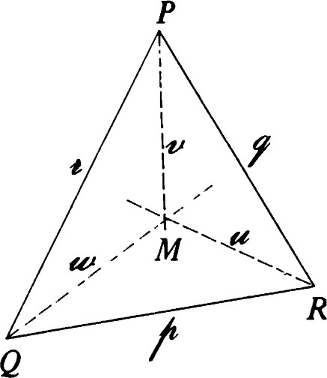

Figure 4.26 Concurrence of the angle bisectors.

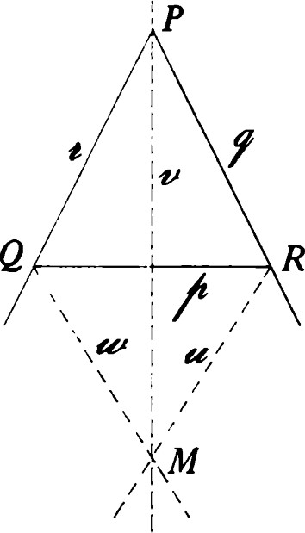

Figure 4.27 Concurrence of exterior angle bisectors with remote interior angle bisector.

1 1 7

Theorem 58. Let G be a finite subgroup ofSO(3). Then G falls into one of the categories listed in the following table.

|  |  |  |  |  |  |  |
| --- | --- | --- | --- | --- | --- | --- |
|  | Order of | Number of orbits | Number of poles | Orders of stabilizers | | |
| cyclic dihedral tetrahedral octahedral icosahedral | n  2n  12  24  60 | 2  3  3  3  3 | 2  14  26  62 | n 2  2  2  2 | n 2  3  3  3 | n 3  4  5 |

Every finite rotation group is conjugate to one of the cyclic or dihedral groups or to one of the three specific groups listed. Our treatment is incomplete. We will show that any finite rotation group has data fitting the table, but we will not show uniqueness for these groups or, in fact, even define the groups explicitly. For more details you may consult Benson and Grove [4] or Yale [35].

We describe the cyclic and dihedral groups explicitly. With respect to an orthonormal basis {el, e2, e3} let a be the rotation whose matrix is

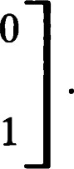21T rot — n o

Then a generates a cyclic group of order n consisting of rotations about e3. Now let ß be the half-turn about el. Then a and ß generate a group satisfying the relations = ß2 = I, ßa = a -l ß. It is easy to check that akß has the matrix

2kTt 2kTt cos sin n n

2k1T 2kqr sin —cos

n n

o -1 and so is a half-turn about the point (cos(kq/n), sin (klT/n), O).

Now let G be a finite subgroup of SO(3). If T is a nontrivial rotation about x, we call x a pole of T. If G has order n, there are 2(n — 1) ordered pairs (T, x) consisting of a nontrivial rotation in G and one of its poles.

1. 1 8 Lemma. G permutes the set of poles.

|  |  |
| --- | --- |
| Proof: Let x be a pole of some rotation T e G, and let R be an element of G. Then  Rx = RTx = (RTR -l )Rx.  Now R TR A is a rotation in G having Rx as a pole. Thus, R maps poles to poles. Similarly, x =  and R —Ix is a pole of R —l TR. We conclude that R is a permutation of the set of poles.  Proof (of Theorem 58): For each pole x let vx = #0rbit(x), and nx — #Stab(x). Then nxvx = n = #G. Now counting the ordered pairs (T, x) gives  k  - 1) = Vi(nz - 1),  where {Xl . . . Xk} are representatives of the disjoint orbits that make up the set of poles. Writing ni — nx and u vx, we get  2(n — 1) = — i).  Thus,  (4.6)  This formula will allow us to determine the number and size of the orbits. First, note that any fixed point of a nontrivial rotation Tin G is also a fixed point of T—l . Thus, we may conclude that ni 2 for all i. Clearly, the number k of orbits cannot be 1 because 2 — 2/n 1. On the other hand, we have  2 1  _ 1 and  and, hence, | Finite rotation groups |

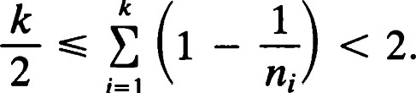

k

i=l

In particular, k < 4, and so the only possibilities for k are 2 and 3.

We first look at the case k = 2. Formula (4.6) reduces to

1. 1 1

# 2 -

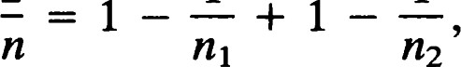

n2

2 1 1 n nl n2

 1 1 9

Thus, VI = = 1, = = n, and there are just two poles. G is a group of rotations around this pair of antipodal points.

The remaining possibility is k = 3. We may assume that n2 113. We first note that = 2 because 3 would give

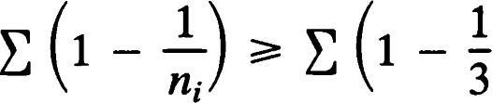1

# - 2 > 2 -

n violating (4.6). With this simplification (4.6) becomes

## 2 -

that is,

2 1 1 1

(4.7)

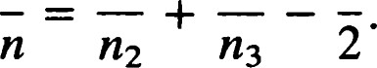

112

In order to make the right side of (4.7) positive, we must have 3. If

= 2, then 2/n = 1/713, and t.'3 = 2. Also, VI = = n/2. On the other hand, n2 = 3 yields

2 1 1 1 1 1

(4.8)

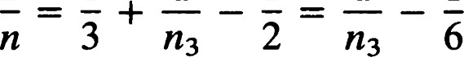

6'

and so < 6. Thus, the remaining possibilities for n3 are 3, 4, and 5. Unlike the previous cases, each possible value for uniquely determines the order n of the group G. Specifically, the possible combinations for ("13, n) are (3, 12), (4, 24), and (5, 60), as can be easily seen from (4.8). 

### Finite groups of isometries of S2

Let G be a finite group of isometries of S2 . Assume that G does not consist entirely of rotations. Choose an element ß that is not a rotation. Then G = Go U ßGo, where Go is the set of rotations in G. Thus, the group G must have order 2n, 4n, 24, 48, or 120, depending on the structure of Go. It is an interesting exercise to determine the group structures that can occur. Among the groups so obtained will be the symmetry groups of the regular polygons of S2 , the "degenerate" regular polygons having all vertices collinear and the regular polyhedra (Platonic solids) discussed earlier in this chapter.

### EXERCISES

1. Prove the properties of cross products stated in parts (i), (iii), and (iv)

120 of the corollary to Theorem 1.

#### 2. Prove Theorem 2. Finite groups of

1. Prove that lines P + [v] and Q + [w] intersect if and only if isometries of S2



1. Assume that the lines of Exercise 3 do not intersect. Find the (shortest) distance between them.
2. Prove Theorem 5.
3. Given three points P, Q, and R of S2 , what calculation can you perform to determine whether P, Q, and R are collinear? Apply it to the points

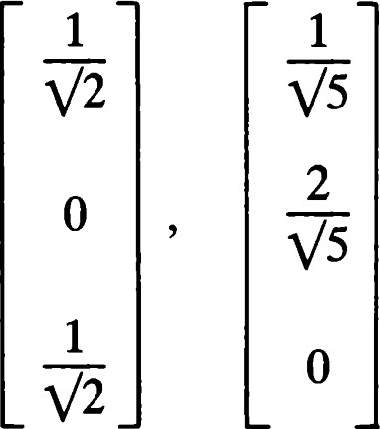 and 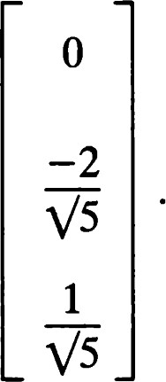

1. Let A and B be distinct points of S2 . Show that

{X s2 1d(X, A) = d(X, B)}

is a line, and find an expression for its pole.

1. Verify statements (i)—(iii) of Theorem 8.
2. Prove Theorem 10.
3. Prove Theorem 11. In particular, show that

i. The poles of are x P)/le x PI, where  is a pole of e. ii. The points of intersection are

•

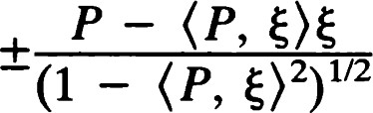

1/2

iii. The distances from P to e are

cos - (P, E) 2 )1/2

1. Prove Theorem 12, part (i) and Theorem 13.
2. Verify that Theorems 15 and 16 can be proved with the same calculations as were used in the Euclidean case.
3. Prove Theorem 21.
4. Let P and Q be distinct nonantipodal points. Under what circumstances will the group generated by {Hp, HQ} be finite? (Note: A half-turn on S2 is again a product of reflections in two perpendicular lines.)
5. Prove Theorem 27 concerning fixed points of isometries.
6. Prove Theorems 28 and 29 concerning fixed lines of isometries. 1 21
7. If an isometry of S2 leaves P fixed and takes Q to —Q, show that



1. Let P = (1, 1, 0) and Q = (3, 2, 1) be points of E3 . Let X = P/IPI, Y = Q/IQI.
   1. Find an orthonormal basis with X as one element and the pole of XY as another.
   2. Compute the matrices of I-Ix and HY (as isometries of S2) with respect to this basis.
2. Classify the isometries of S2 satisfying a4 = I. (You may use the fact that isometries, motions, and orthogonal transformations are essentially the same thing.)
3. Find all isometries a of S2 such that a2 = I, but a * I. Such an isometry is said to be an involution. If a and ß are involutions, is aß an involution?
4. Let P be a point of S2 , and e a line of S2 . Show that (OeHp)2 — I

if and only if P is a pole of C or P e

1. If a -L 6 and 6 -L c, what is 000602
2. Verify the following formula for a half-turn:

Hpx = 2K X, - X.

1. Let e be a line of S2 with pole P. Show that {I, Hp, Oe, E} is a group, and give its multiplication table. (E is the antipodal map.)
2. Without using Euler's theorem, show that the product of two rotations is a rotation.
3. Let -y be a glide reflection. Prove that has exactly two (antipodal) fixed points unless -y is a reflection or -y = E.
4. Let e be a line. Find g
5. Let ef = {P, Q, R} be a figure consisting of three mutually perpendicular points. Find g (9).
6. Under what circumstances will a reflection and a half-turn commute?
7. Prove or disprove the formula

HpHQHR = HRHQHp.

1. Let P be a point of S2 . Show that the stabilizer of P in 0(3) consists of the rotations about P and the reflections in lines through P.
2. Let e, m, and be mutually perpendicular lines, and let L, M, and N be respective intersection points m n n, n n e, and e n m. Show that {Oe, On, On, HL, HM, HN, E, I} is a group and that 1 22 {HL, HM, HN, I} is a subgroup.
3. Fill in the missing argument in the proof of Theorem 35.
4. Let P, Q, and R be distinct points of S2 . Assume neither Q nor R are antipodal to P. Prove that PQ = PR if and only if P, Q, and R are collinear, Q lies on PR, or R lies on PQ. (PR and PQ are taken to be minor segments.)
5. Verify that {Xl (X, E) O} is a half-plane. Does the crossbar theorem hold in S2?
6. Although a given angle can be represented in many ways, the definition of its radian measure is independent of the representation. Prove this.
7. Complete the proof of Theorem 38.
8. Adapt the Euclidean material on rectilinear figures (Chapter 2, Theorems 24, 25, and their corollaries) to spherical geometry. Verify that spherical triangles have the same symmetry properties as Euclidean triangles.
9. Verify the remark following Theorem 46.
10. Show that the line to in the corollary to Theorem 54 contains the bisector of 4PQR.
11. Prove that the product of reflections in the perpendicular bisectors of the sides of a triangle is a reflection whose axis passes through a vertex.

#### Finite groups of isometries of S2

1 23